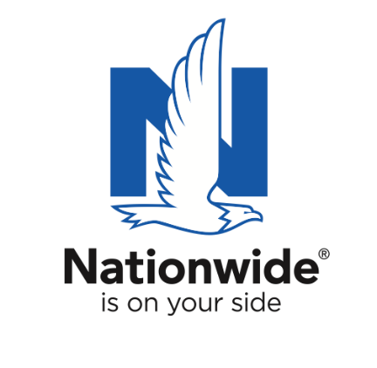
FOR IMMEDIATE RELEASE

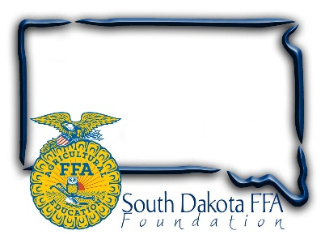
October 1, 2024

Contact:
Gerri Eide
SD FFA Foundation
gerri@sdffafoundation.org
605-765-4865

Nominate Local Teachers for Top South Dakota
Agricultural Educator Award

Nationwide’s Golden Owl Award® honors extraordinary
agricultural educators across 13 states

Bath, SD – Agriculture educators play a crucial role within their communities by investing countless hours to prepare and empower students for successful careers in the industry.
In recognition of their invaluable contributions and to offer additional resources for their programs, Nationwide introduced the Golden Owl Award in 2018.

Since its inception, the Golden Owl Award has awarded nearly half a million dollars to support teachers, students, school agricultural programs and FFAs. Last year, there were over 3,500 nominations across 11 participating states. Due to its positive impact and popularity, the award is expanding this year to include Kentucky and Maryland.

“Agricultural educators are so much more than teachers; they’re community servants who are shaping the leaders of tomorrow,” said Brad Liggett, president of Agribusiness at Nationwide. “Together with our partners, we encourage students, parents, fellow teachers and other community members to nominate their agricultural teachers to acknowledge their hard work.”

The South Dakota FFA Foundation is now accepting nominations for South Dakota’s top agricultural teachers for a chance to be named as the Ag Educator of the Year. Nominate any South Dakota agriculture educator for the 2023-2024 Golden Owl Award Oct. 1st through Dec. 31 at www.sdaged.org/GOA or by scanning the code.

After the nomination period closes on December 31, 2024, a selection committee will evaluate nominations and select eight finalists in South Dakota. These finalists will be recognized in front of their peers and students, receiving a personalized plaque and $500 award. One finalist will then be chosen as the grand prize winner, earning the 2024-2025 Ag Educator of the Year title for South Dakota, along with the coveted Golden Owl Award trophy and an additional $3,000 to help fund future educational efforts.

The 2023-2024 Golden Owl Award recognized 79 exceptional agricultural teachers, including 11 Ag Educators of the Year. This year, the award program will recognize leading agricultural teachers across 13 states: California, Illinois, Indiana, Iowa, Kansas, Kentucky, Maryland, Missouri, Nebraska, New York, Ohio, Pennsylvania and South Dakota.
Nationwide is committed to supporting the future of the ag community through meaningful sponsorships of national and local organizations. In conjunction with the Golden Owl Award, Nationwide is donating $5,000 to each participating state’s FFA, including the South Dakota FFA Foundation, to further support the personal and professional growth of students, teachers and advisors alike.

The owl, a symbol of knowledge and wisdom, is one of the five symbols in the FFA emblem. It inspired the name of the Golden Owl Award program, reflecting the dedication and investment agriculture teachers make to empower their students.

To learn more about the Golden Owl Award, visit GoldenOwlAward.com.

About Nationwide
Nationwide, a Fortune 100 company based in Columbus, Ohio, is one of the largest and strongest diversified financial services and insurance organizations in the United States. Nationwide is rated A+ by Standard & Poor’s. An industry leader in driving customer-focused innovation, Nationwide provides a full range of insurance and financial services products including auto, business, homeowners, farm and life insurance; public and private sector retirement plans, annuities and mutual funds; excess & surplus, specialty and surety; and pet, motorcycle and boat insurance.
For more information, visit www.nationwide.com.
Subscribe today to receive the latest news from Nationwide and follow Nationwide PR on X.
Nationwide, Nationwide is on your side and the Nationwide N and Eagle are service marks of Nationwide Mutual Insurance Company. © 2024

